Hard Reset

Hard Reset is a PC exclusive cyberpunk shooter from the developers Flying Wild Hog. Set in the fictional city of Bezoar during 2436 you take the role of Fletcher, a soldier who battles hordes of robot nasties. The game will feel familiar if you have played Painkiller or Serious Sam but it crafts a unique style. It is designed around the use of two types of upgradeable weapons, energy and projectile based. The game engine produces outstanding weapon effects, crisp textures and wonderful lighting. The central focus of the entire game is on the two weapons that require patience to use properly.

[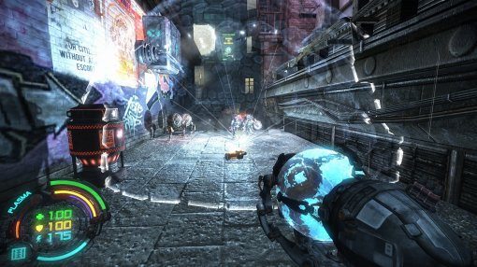](http://www.newgamenetwork.com/media/6707/hard-reset/)  
**A stasis field helps when these little critters are about**

Hard Reset revolves around the use of two weapons, each with diverse upgrades. The projectile based CLN Firearm can be a machine gun, grenade launcher or a rocket launcher. The N.R.G. weapon can be a rail gun with x-ray vision, a Tesla coil or an electric mortar. These upgrades are installed at special stations spread throughout the game. Upgrades are bought using currency that is found in secret areas and gained from killing enemies. Modes added to your weapons can be cycled through just like a regular shooter. There can be a long delay when switching weapons and firing modes, creating a unique game speed.

Certain weapon modes take seconds to recharge and you can’t change to other modes quickly. Using a mode incorrectly can have dire consequences. Your crosshair indicates the selected weapon mode and shows when you can fire again. As the weapon switch is slower than similar shooters you need to move around and search for health dropped as robots continue to attack. There is a good deal of satisfaction from using the weapons well. You might create a stasis sphere with your NRG weapon and then lob some grenades into stationary enemies within. Chokepoints can be exploited by placing several electric mortars that fry small robots trying to get through.

Additional upgrades can be placed on combat armor instead of your two weapons. You can install an ability that slows time when you are sufficiently low on health. This gives you enough time to capture health orbs or just finish off irritating robots about to turn you into chow. You can also increase health, ammo reserves or improve regenerating armor. More and larger enemies are thrown at you as you progress creating a natural difficulty curve that corresponds well with weapon upgrades. The robots still make it rather difficult and there is no time for complacency.

[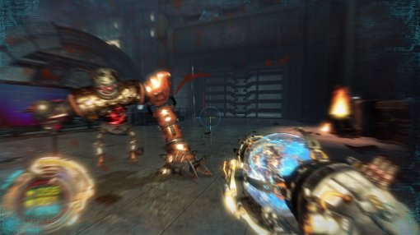](http://www.newgamenetwork.com/media/6718/hard-reset/)  
**This is far too close for comfort**

The AI poses a significant challenge on normal and they will make you feverishly avoid close contact. They tend to move considerably faster than you and can dodge side to side when moving down corridors. You can use the environment to block enemies but this is generally ineffective as their navigation systems locate you quickly. Smaller melee robots have a saw that quickly turns you into mush and this saw may harmlessly spin toward you after they die. Some gorilla type robots will aggressively charge you and follow up with a ground pound. Thankfully objects in the environment are useful offensive tools.

Environmental objects are incredibly deadly and will cause you to shift weapon focus at opportune times. Cars explode, explosive barrels catch fire and cause chain reactions, computer systems send out arcs of damaging electricity. These environmental objects are strategically placed in larger combat areas. Backing into an explosive barrel as a gorilla type robot charges is not a good idea. You can corral enemies towards these hazards but it’s not quite as fun as the environmental interaction in Bulletstorm. The phenomenal effects associated with these environmental objects are part of the reason why the game looks incredible.

[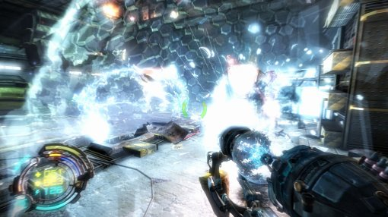](http://www.newgamenetwork.com/media/6710/hard-reset/)  
**Amazing weapon effects can be a little overbearing**

The custom engine for Hard Reset produces glorious visuals at an incredibly smooth frame rate. Textures are crisp, shadows look natural and the high dynamic range lighting is very impressive. Computer terminals and upgrade stations display a seamless mouse cursor like in Doom 3. The levels are tiered or go around in loops requiring little need for the built in compass. The various effects are great but they sometimes get in the way of the enemies. It’s almost impossible to see beyond one electric mortar let alone two.

The story in Hard Reset is minimal and told mostly through drawn cut scenes with voice over shown between the levels. Although the level pacing is good the story was quite hard to follow and ended abruptly after a boss battle. The story tries desperately to link with the disconnected levels when a character becomes a voice in your head. The story at least provides the framework for your goals and situation but perhaps more in game story would have helped. Levels also ended unexpectedly in the middle of a room which diminished the good pacing.

The pacing in Hard Reset is alternates well between taxing combat and slow exploration. Some areas you enter close the door behind you and this will give you a good indication that hell is about to break lose. Once the battle is over you can leisurely investigate the areas for currency in secret corners. Occasionally these secrets are combined with additional enemy spawns which may catch you by surprise. There are no puzzles or gimmicks outside the standard two weapon system that proves sufficient.

[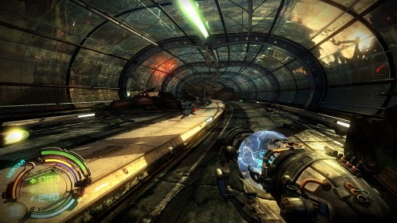](http://www.newgamenetwork.com/media/6725/hard-reset/)  
**Nothing could possibly go wrong down this tunnel**

Less than five hours will have expired when the last robot falls at your feet. Although short Hard Reset is a good shooter that is as satisfying as it is attractive. The cyberpunk world is beautiful and the level design flows well with plenty of secrets to find. Robots pose a threat and the upgrade system works to produce a difficulty curve that remains fair throughout. If you die it will be because you have used your weapons poorly. The deliberate and slower switch weapon style creates tense combat. Hard Reset is a fine PC shooter that looks and plays as good as big budget titles.